Smart Pest Repeller

Andrew Albritton

Mequisedec Ordonez

Michael McNeil

**Concept of Operations**

REVISION

14 September 2023

Concept of Operations

for

Smart Pest Repeller

Team 30

Approved by:

_____________________________

Project Leader Date

_____________________________

Prof. Kalafatis Date

_____________________________

T/A Date

**Change Record**

| **Rev.** | **Date** | **Originator** | **Approvals** | **Description** |
| --- | --- | --- | --- | --- |
| **0** | 9/12/23 | ALL |  | Draft Release |
| **1** | 9/28/23 | ALL |  | Midterm Report ICD & FSR additions |

**Table of Contents**

**Table of Contents** **3**

**List of Tables** **4**

**List of Figures** **5**

**1.** **Executive Summary 6**

**2.** **Introduction 7**

2.1. Background 7

2.2. Overview 7

2.3. Referenced Documents and Standards 7

**3.** **Operating Concept 8**

3.1. Scope 8

3.2. Operational Description and Constraints 8

3.3. System Description 8/9

3.4. Modes of Operations 9

3.5. Users 9

3.6. Support 9

**4.** **Scenarios 9**

[4.1. Garden or Small Outdoor Area Use](https://docs.google.com/document/d/1iq4HAmX-esDczZtWkM9OUoNf8X_QaAYC/edit#heading=h.2bn6wsx) 9/10

4.2. Commercial Use……………………………………………………………………………10

**5.** **Analysis 10**

5.1. Summary of Proposed Improvements 10

5.2. Disadvantages and Limitations 10

5.3. Alternatives 10

5.4. Impact 11

**List of Tables**

No table of figures entries found.

**List of Figures**

# Fig 1.1 - Subsystem Operational Flow Chart

# Executive Summary

Controlling the presence of pests is a task that can be a struggle for various different aspects of life. The goal of the Smart Pest Repeller is to address this issue as easily as possible for users while also mitigating potential hazards that come with alternative methods of pest control. The Smart Pest Repeller will utilize a camera and machine learning program in order to sense the presence of pests in the area through image processing. This will send a signal to an ultrasonic sound emitter that would activate to repel any pests that were sensed. The device will be able to function while plugged into a wall or on its own in order to maximize effective use situations. This will decrease the manpower and resources needed to address pest control in commercial, agricultural, and residential settings.

# Introduction

There are many pest control options on the market. Each of these options have some negative aspects that consumers may need to consider when deciding how to approach their pest control problems. The goal of the Smart Pest Repeller is to create the best solution to these problems while mitigating potentially negative aspects of pest control.

## Background

The current standard for pest control employed by most residential or commercial users currently is either the use of pesticides and other harsh chemicals or the implementation of different ultrasonic sound systems than the Smart Pest Repeller system. The limitations and drawbacks of these methods is what we are seeking to address with the Smart Pest Repeller. Since SPR is using image processing sensing technology to identify pests, it will not activate in the presence of humans or other pets and will instead target specific pests. This solution will mitigate the need for harsh chemical pesticides while also introducing a solution that targets specific pests and does not act as a hindrance to anything else.

## Overview

The system will use a camera connected to a controller unit that will be running a program to process the images received. When the program reads that there is a pest detected in the image it will send a signal to the ultrasonic sound emitting device that will act as the pest control mechanism. Once the pest is no longer detected in the area the system will turn off the sound emitter and wait until another pest is detected. The unit will be able to plug into the wall and run directly from wall power or be able to function disconnected from the wall on battery power as well.

## Referenced Documents and Standards

* Rechargeable [Battery Standards - Lithium, Nickel Metal Hydride, Nickel Cadmium (epectec.com)](https://www.epectec.com/batteries/battery-standards.html)
* OSHA Speaker/Workplace sound [OSHA Technical Manual (OTM) - Section III: Chapter 5 | Occupational Safety and Health Administration](https://www.osha.gov/otm/section-3-health-hazards/chapter-5)

# Operating Concept

## Scope

The proposed system will be designed primarily for outdoor use in agricultural settings, small gardens or farms. It will be able to detect medium to larger insects in addition to smaller reptiles. The camera will not be able to detect small insects such as mosquitos or small flies and will therefore not repel these. The camera will also limit when the device can be used since during night time and in low light environments visibility will be an issue for the camera used for detection. The device will have a battery that will need to be charged so it will occasionally be limited to near the home or make use of an extension cable for uses away from the home while charging.

## Operational Description and Constraints

The repeller will be used outdoors in a well-lit environment. The repeller will use a camera that captures an image of the environment about once every second and send it to a microcontroller. This will be sent to an image detection system that determines if there are any pests in the frame. If a pest has been identified in a frame the microcontroller will send a signal to a speaker that will emit an ultrasonic soundwave to repel the pest. Once a pest is out of frame the speaker stops emitting and waits until it receives a new signal to begin emitting again.

The smart repeller will be limited to environments with decent to high light exposure and will not work during times of low light visibility, at night or moments with overcast for example.

## System Description

The Smart Pest Repeller will consist of three major components; the power unit, the camera and ultrasonic transmitter interface, and the microcontroller.

The power unit can operate either plugged into a traditional wall outlet or independently via a rechargeable lithium-ion battery system. While plugged into a wall outlet, the system will be able to run while also charging the battery for possible wireless use in the future. If not connected to a wall outlet the battery will continue to power the system, the system will also keep track of the fuel levels of the battery and alert the user when a recharge is needed for the battery system.

The camera is controlled by a python program on the Coral board. This program will be automated to take a photo at 1 frame per second. The microcontroller will use a machine learning, ML, algorithm to classify objects in the image. The four choices of classification or labels for the model will be: Flies, Lizards, Rodents, and Idle. Each time an image is done processing one of the above modes will be active.

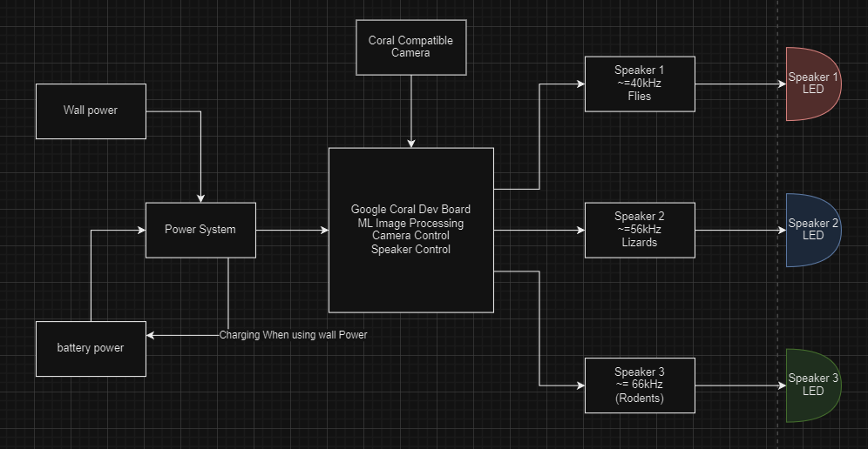

***Fig 1.1***

## Modes of Operations

The system will have one mode of operation and that will simply be “active”. In active mode the system will continuously run the camera and take in data that will be processed in real time to see if there is a pest present. Once the system detects a pest in the target area the emitter will turn on in order to remove pests from the area. Once the camera no longer detects the presence of pests, the system will turn off the emitter and continue to monitor for pests in the target area.

## Users

The Smart Pest Repeller could be marketed to any group of individuals from the individual homeowner to the commercial farmer. This is a great solution to pest control in small areas and could be deployed to cover much larger areas if multiple devices are used. It will act as an eco-friendly solution to the everyday pest problems that users may encounter.

## Support

Support for the Smart Pest Repeller will come in the form of a manual that will describe how the system works and how to operate it as well as a brief description of each subsystem in place in the system for troubleshooting purposes.

# Scenario(s)

## Garden or Small Outdoor Area Use

The Smart Pest Repeller will be best suited to smaller outdoor areas or gardens. This will be an ideal location for the SPR as the camera system will have a hard time sensing pests the further they are away so this system will be optimized for use in locations such as backyard gardens or lounge areas. The system will do great in these settings as it will likely be checked on by users more frequently than a device that is just left in the field so charging will be common enough to not be an issue. The system will also not target any pets that could be a concern for the user.

## Commercial Agriculture

The Smart Pest Repeller could also be used on bigger portions of land that would be used in farming operations but the amount of devices used may vary depending on the size of the land. Since the camera can only see so much in detail it will be more difficult to apply the camera sensing technology to a larger farm setting but if there are multiple systems in place that are strategically located, the system results should be similar to the results of using one device in a smaller area.

# Analysis

## Summary of Proposed Improvements

The recent models of “Smart Pest Repellers” are motion based, or constantly emit high frequency sound. Our device will utilize a machine learning algorithm which will differentiate between undesirable and desirable organisms. For example, a bee pollinating your garden is desirable, while a grasshopper would damage fauna. We would want to allow bees to pollinate, but if there are undesirable organisms present we will turn the high frequency emitter on.

## Disadvantages and Limitations

The disadvantages of the Smart Pest Repeller system is that since the system will be constantly running a machine learning algorithm for image processing, there will be a significant increase in power needs for the system to function. The system will also be less effective at night time since it is using image processing to detect pests and at night the camera visibility will decrease drastically. The system will also be contained in a housing unit that will take up more space than the alternative solutions such as plug-ins or citronella candles.

## Alternatives

Many alternatives to the Smart Pest Repeller already exist on the market but each of these has different limitations of their own. Pesticides are a very common solution to the pest problem, but they also have significant drawbacks in the form of polluting the environment and also exposing unintended organisms to harmful chemicals such as other humans and pets. Other ultrasonic sound repellent systems also exist but they have limitations such as always emitting, sound having to be plugged into a wall power outlet perpetually, or always emitting the same frequency (lizards, rodents, and flies react to separate frequencies: 52-60kHz, 60-72kHz, and 38-44kHz respectively)

## Impact

For the average gardener, our device will provide protection from not only flies, but rodents and lizards as well. We will be using our machine learning algorithm to differentiate between the animals listed above; this allows for differing frequency outputs from our sound source, allowing for effective pest control from most possible invaders. It can also be noted with other devices, organisms become accustomed to the constant presence of high frequency sound over time causing the device to lose its effectiveness. Our device will only trigger while there is a pest detected, this allows for an irregular pattern of sound, thus causing adaptation to the device to become more difficult for pests. High frequency pest control is considered one of if not the most humane method of pest control currently, and our device will allow for a broader range of application than the devices currently on the market.

Smart Pest Repeller

Andrew Albritton

Michael McNeil

Melquisedec Ordonez

**Functional System Requirements**

REVISION – Draft

25 September 2023

Functional System Requirements

for

Smart Pest Repeller

Prepared by:

_____________________________

Author Date

Approved by:

_____________________________

Project Leader Date

_____________________________

John Lusher, P.E. Date

_____________________________

T/A Date

**Change Record**

| **Rev.** | **Date** | **Originator** | **Approvals** | **Description** |
| --- | --- | --- | --- | --- |
| **0** | 9/25/23 | ALL |  | Draft Release |
| **1** | 11/5/23 | ALL |  | update |
| **2** | 3/29/24 | Andrew A |  | Addition of test case |

**Table of Contents**

**Table of Contents** **16**

**List of Tables** **17**

**List of Figures** **18**

**1.** **Introduction 19**

1.1. Purpose and Scope **19**

1.2. Responsibility and Change Authority **19**

**2.** **Applicable and Reference Documents 20**

2.1. Applicable Documents **20**

2.2. Reference Documents **20**

2.3. Order of Precedence **21**

**3.** **Requirements 22**

3.1. System Definition **22**

3.2. Characteristics **23**

3.2.1. Functional / Performance Requirements **23**

3.2.1.1. Variable Pest Responses **23**

3.2.1.2. Search Probability of Detection **23**

3.2.1.3. Image Classification Distance **23**

3.2.2. Physical Characteristics **24**

3.2.2.1. Volume Envelope **24**

3.2.2.2. Mounting **24**

3.2.3. Electrical Characteristics **25**

3.2.3.1. Inputs **25**

3.2.3.1.1. Power Consumption **25**

3.2.3.1.2. Input Voltage Level **25**

3.2.3.2. Outputs **26**

3.2.3.2.1. Data Output **26**

3.2.3.2.2. Diagnostic Output **26**

3.2.3.3. Wiring **26**

3.2.4. Environmental Requirements **27**

3.2.4.1. Thermal **27**

3.2.4.2. Rain **27**

3.2.4.3. Humidity **27**

3.2.5. Failure Propagation **28**

3.2.5.1. Failure, Detection, Isolation, and Recovery **28**

3.2.5.1.1. Built In Test (BIT) **28**

3.2.5.1.2. BIT False Alarms **28**

**Appendix A Acronyms and Abbreviations** **29**

**Appendix B Definition of Terms** **30**

**List of Tables**

**Table 1. Subsystem Assignments 20**

**List of Figures**

**Figure 1. Project Conceptual Image** 19

**Figure 2. Block Diagram of System** 22

# Introduction

## Purpose and Scope

The purpose of this document is to describe the system requirements for our assigned project. Our assigned project’s purpose is to provide an alternative solution for high frequency based pest control. Current pest control models only target one subset of organisms (IE: rodents, flies, or larger mammals), our device shall be able to target a range of organisms including: flies, rodents, and lizards. The system shall output a specific frequency corresponding with the found organism. This frequency will cause organisms to vacate the effective area of the transmitter.

Figure 1 shows a conceptual finished product as proposed in the CONOPS report.

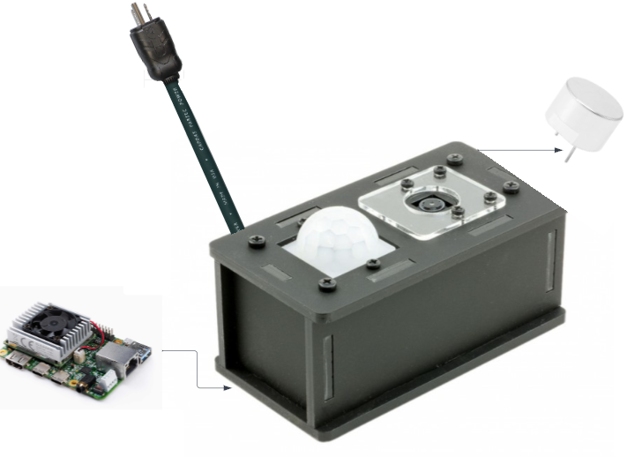

**Figure 1. Project Conceptual Image**

## Responsibility and Change Authority

The team leader, Melquisedec Ordonez, will be responsible for ensuring that all requirements are met. These requirements can be changed with the approval of the team leader and sponsor Peng Hao Huang.

| **Subsystem** | **Assigned Member** |
| --- | --- |
| Power Supply and Battery System | Michael McNeil |
| Machine Learning Algorithm, Motion Sensor, and Camera Interface | Andrew Albritton |
| Signal Generation and Transmission | Melquisedec Ordonez |

*Table 1: Subsystem Assignments*

# Applicable and Reference Documents

## Applicable Documents

The following documents, of the exact issue and revision shown, form a part of this specification to the extent specified herein:

NOTE: examples below, make sure what you use really is what you want to follow!!!! I really would not call out MIL-STD-810 for your project!

| **Document Number** | **Revision/Release Date** | **Document Title** |
| --- | --- | --- |
| [ultralytics/yolov5: YOLOv5 🚀 in PyTorch > ONNX > CoreML > TFLite (github.com)](https://github.com/ultralytics/yolov5/tree/master) | 22 November 2022 | YOLOv5 GitHub |
| 978-1-5090-0917-6 | 16-19th October 2016 | An Overview of the Fundamentals of Battery Chargers |
| G950-01455-01 | December 2022 | Coral Dev Board Datasheet |
| <https://universe.roboflow.com/texas-am-at-college-station/smart-pest-repeller-detection> | 10/15/23 | Image Database with source credit |
| <https://github.com/drasafasforis/edgetpu-yolo.git> | 11/4/2023 | forked GitHub repository of edge tpu compatible model operation, from [Josh Veitch-Michaelis](https://github.com/jveitchmichaelis) |
|  |  |  |
|  |  |  |
|  |  |  |
|  |  |  |
|  |  |  |
|  |  |  |
|  |  |  |
|  |  |  |

## Reference Documents

The following documents are reference documents utilized in the development of this specification. These documents do not form a part of this specification and are not controlled by their reference herein.

| **Document Number** | **Revision/Release Date** | **Document Title** |
| --- | --- | --- |
| 978-1-5386-5368-5 | 28-29th December 2018 | Smart Ultrasonic Insects & Pests Repeller for Farms & Inventories Purpose |
| 1910.305 | 16 January 1981 | Wiring methods, components, and equipment for general use. |
| 1521-3331 | March 2002 | Humidity management of outdoor electronic equipment: methods, pitfalls, and recommendations |

## Order of Precedence

In the event of a conflict between the text of this specification and an applicable document cited herein, the text of this specification takes precedence without any exceptions.

All specifications, standards, exhibits, drawings or other documents that are invoked as “applicable” in this specification are incorporated as cited. All documents that are referred to within an applicable report are considered to be for guidance and information only, except ICDs that have their relevant documents considered to be incorporated as cited.

# Requirements

*This section defines the minimum requirements that the development item(s) must meet. The requirements and constraints that apply to performance, design, interoperability, reliability, etc., of the system, are covered.*

## System Definition

The Smart Pest Repeller will run from power supplied via a battery or wall power. While in operation it will be monitoring for any possible pest activity. Once a pest is detected the ML algorithm will process the image and see if the organism present falls into one of the preset categories created for the program. If the organism is identified as belonging to one of those groups, then the emitter will output the corresponding frequency of sound until the system no longer detects the pest.

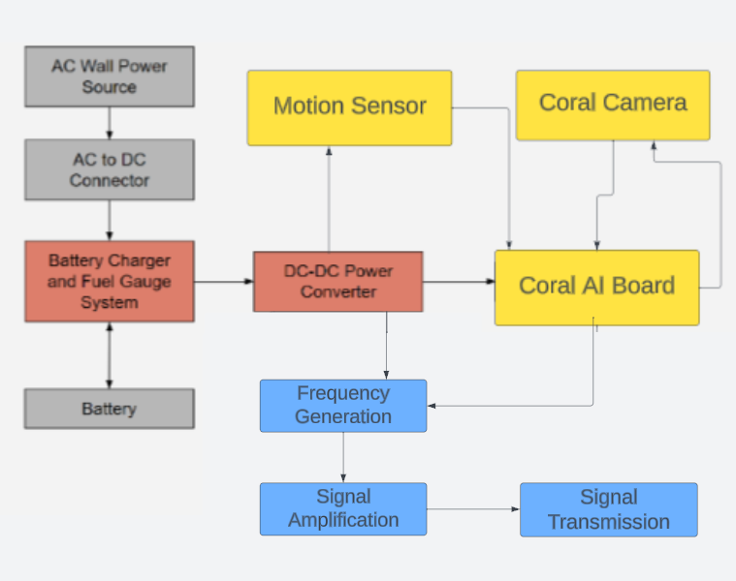

**Figure 2. Block Diagram of System**

*Describe the block diagram, what are the subsystems, how do they interconnect. Someone reading this section should get a general idea of what you are building, why, and how it will solve the problem you are solving.*

The power supply and battery system will ensure that the pest repeller system will be able to work while connected to a wall power source or on its own. While connected to the wall power source the system will use the wall power as the main source of power while charging the batteries via the battery charger circuit. The charging circuit will monitor the battery as it charges, ensuring that the battery does not over charge and potentially suffer damage. While the system receives power from the battery source the fuel gauge will monitor the batteries fuel levels. Once the battery fuel level reaches a point where the system needs to charge again soon, the system will have a light indicator to tell the user that the system needs to charge. The power system will also incorporate a DC to DC converter in order to ensure the voltage being sent to the microcontroller is consistent and usable at around 5 volts and 2 amps of output. Once motion is detected the photo taken by our Coral AI camera will be sent to the Coral AI dev board for image processing. This processing shall be done using an image recognition ML model.

The transmitter shall emit frequencies of: 38-44 kHz, 52-60 kHz, and 60-72 kHz. The emitter will receive its signal from a direct digital synthesizer(DDS). It will generate the unique signal for the pest in question and deliver it to the emitter for transmission. The signal is then amplified as needed for the emitter. Only one emitter and therefore one frequency will be used at a time. For multiple pests in the frame of the camera the repeller will target one pest until it is out of frame. The emitter will then emit a new frequency for the remaining pest(s) until all pests are out of frame of the camera.

## Characteristics

### Functional / Performance Requirements

#### **Variable Pest Responses**

The system will have 3 different types of frequency responses based on the pest that is present.

*Rationale: This is a requirement asked by the sponsor as the drawbacks of other systems are limited frequency responses.*

#### **Search Probability of Detection**

The Smart Pest Repeller classification subsystem shall have a probability of 90% of detection.

*Rationale: Most image classification algorithms settle to 85-93% after extensive training, so our goal will be to reach a slightly above average detection rate.*

#### **Image Classification Distance**

The Smart Pest Repeller shall have a classification distance of a maximum of 8ft for large rodents / large lizards. Classification distance for small organisms may vary depending on given size (ie: fruit flies <2ft). Minimum distance of classification for larger organisms shall be 2ft.

*Rationale: The image classification model being used will have a larger chance of guessing the correct species, when said organism takes up greater space on camera. Organisms can also be too close, taking up too much space in the image, preventing classification.*

### Physical Characteristics

#### **Volume Envelope**

The system shall have a maximum size of 6x6x14in, or the size of a shoe box. This box shall have openings allowing for image and motion sensing, as shown in figure 1. The mass of the system shall not exceed 10kg.

*Rationale: The size and mass will allow for deployment of the system to take place by hand.*

#### **Mounting**

The mounting height of the Smart Pest Repeller will be at a height of 2 ½ ft from the ground.

*Rationale: This will ensure proper image quality for processing and reduce possible classification errors.*

### Electrical Characteristics

#### **Inputs**

1. The presence or absence of any combination of the input signals in accordance with ICD specifications applied in any sequence shall not damage the Smart Pest Repeller, reduce its life expectancy, or cause any malfunction, either when the unit is powered or when it is not.
2. No sequence of command shall damage the Smart Pest Repeller, reduce its life expectancy, or cause any malfunction.
3. Motion sensor input shall be utilized to trigger the device’s camera to take a photo.

*Rationale: By design, should limit the chance of damage or malfunction by user/technician error. Also, motion detection should limit the need for constant data processing, saving power usage.*

##### Power Consumption

The maximum peak power of the system shall not exceed 20 watts.

*Rationale: This is a requirement in order to achieve the desired battery life outlined by the sponsor*

##### Input Voltage Level

The input voltage to the entire system will be a 120 Volt AC signal from a wall outlet.

*Rationale: This allows the system to work via wall power*

***3.2.3.1.3* Power PCB Output**

The power management PCB outputs 5V 2A signal

*Rationale: This is the signal needed to power MCU*

***3.2.3.1.4* Battery Charger Output**

Battery charger outputs 7.2 V voltage to battery.

*Rationale: This is the signal needed to charge the battery when in charging mode*

***3.2.3.1.5* Fuel Gauge**

Battery fuel gauge tracks cell voltages of battery. When battery fuel reaches 20% the MCU shall shut off and a message will be displayed on the UI screen to tell the user to plug the device to wall power.

***3.2.3.1.6* Power PCB System Functions**

The power management PCB functions as desired by charging a 7.2 V battery when attached to wall power and constantly powering MCU and other power needing components, via battery or wall power.

#### **Outputs**

##### Data Output

The Coral Dev board shall communicate with the emitter subsystem using SPI in order to emit frequency corresponding to detected organisms.

*Rationale: The smart pest repeller must output the corresponding frequency to the found pest in order to have effective pest control.*

##### Diagnostic Output

The Smart Pest Repeller shall have a UI screen marking when the battery needs to be charged.

*Rationale: Provides the ability to know when the device will need to utilize wall power.*

*.*

#### **Wiring**

The Smart Pest Repeller shall follow guidelines provided in document 1910.305 for wiring standards.

*Rationale: Conform to equipment for general use standard of OSHA guidelines*

### Environmental Requirements

The Smart Pest Repeller System shall be designed to withstand and operate in the environments and laboratory tests specified in the following section.

*Rationale: The device must be able to function consistently outdoors.*

#### **Thermal**

The smart pest repeller shall be able to function in a temperature range of 0℃-40℃

*Rationale: Average outdoor temperature within the United States falls within the range shown above.*

#### **Rain**

The Smart Pest Repeller shall function in light rain, while it is suggested that the device be taken inside during flooding.

*Rationale: The device should function in light rain but if there is a risk of the power cord being submerged in water or having contact with water, the device should be brought inside to prevent unwanted shorts.*

#### **Humidity**

We will be adhering to the IEEE standard for humidity and outdoors circuits in document 1521-3331.

**3.2.4.4 Garden Tests**

The Smart Pest Repeller shall detect rats, squirrels, lizards, and flies in a garden environment, and emit corresponding frequency to animals detected with sufficient volume to deter pests.

*Rationale: This environment is the suggested application of our device, so it would be suitable to test in this area.*

### Failure Propagation

The Smart Pest Repeller shall not activate its high frequency transmitters on false activation of motion sensor.

#### **Failure Detection, Isolation, and Recovery (FDIR)**

##### Built In Test (BIT)

The Smart Pest Repeller image recognition shall ignore when the three labels provided (fly, rodent, or lizard) have a low confidence margin or are not triggered. This test will be run 50 times to ensure detection before triggering an output.

*Rational: This test will assist in lowering false triggers of the device when nothing is present, or when a person/dog triggers the motion sensor*

###### 3.2.5.1.2 BIT False Alarms

False alarm rate shall be no more than 10%.

*Rationale: Error of the model will be around 10%, but checking over three different iterations will allow for results to be averaged and compared, allowing for mitigated false alarms below 10%.*

# 

# Appendix A: Acronyms and Abbreviations

AC Alternating Current

DDS Direct Digital Synthesizer

DC Direct Current

GPIO General Purpose In-Out port

Hz Hertz

MCU Microcontroller unit

ML Machine Learning

MLA Machine Learning Algorithm

BIT Built-In Test

ICD Interface Control Document

kHz Kilohertz (1,000 Hz)

LED Light-emitting Diode

mA Milliamps

mW Milliwatts

PCB Printed Circuit Board

TBD To Be Determined

# Appendix B: Definition of Terms

DC-DC converter: A circuit or device capable of sending a current from one voltage level to another, higher or lower than the original, input, signal.

Direct Digital Synthesizer: A device capable of producing a digital signal, typically sinusoidal, and converting it into an analog one.

(Ultrasonic) Emitter: A device, typically based on crystals and using the piezoelectric effect, that is able to take an electrical signal and convert it into an audio signal; can be an ultrasound signal as well.

Image Processing: The process of converting a digital image and separating it into bits of useful information that aids in a larger process, eg. recognizing certain traffic signals for autonomous driving vehicles.

.

Machine Learning: The use of computers to perform specific tasks without explicit instructions from a user. Instead the computer is given a set of models and statistical tools that it uses to extract and analyze data to perform desired action(s) on its own.

Microcontroller: a, typically small, integrated circuit that is able to control a certain set(s) of operation(s). Unlike a full personal computer a microcontroller is not required to run on an operating system.

Smart Pest Repeller

Andrew Albritton

Michael McNeil

Melquisedec Ordonez

**Interface Control Document**

REVISION – 0

28 September 2023

Interface Control Document

for

Smart Pest Repeller

Prepared by:

_____________________________

Author Date

Approved by:

_____________________________

Project Leader Date

_____________________________

John Lusher II, P.E. Date

_____________________________

T/A Date

**Change Record**

| **Rev.** | **Date** | **Originator** | **Approvals** | **Description** |
| --- | --- | --- | --- | --- |
| **0** | 9/25/23 | ALL |  | Draft Release |

**Table of Contents**

**List of Tables 34**

**List of Figures****36**

**1. Overview** **37**

**2. References and Definitions** **38**

2.1 References 38

2.2 Definitions 38

3. Physical Interface **39**

3.1 Weight 39

3.2 Dimensions 39

**4. Thermal Interface** **40**

**5. Electrical Interface** **41**

5.1 Primary Input Power 41

5.2 Signal Interfaces 42

5.3 Video Interfaces 42

**6. Communications / Device Interface Protocols** **43**

6.1 Host Device 43

6.2 Device Peripheral Interface 43

**List of Tables**

**Table 1. System Weights 39**

**Table 2. System Dimensions 39**

**Table 3. Maximum Power Delivery Values 41**

**Table 4. Standard Operating Delivery Values 42**

**List of Figures**

# Figure 1. Electrical Interface Diagram 41

# Overview

This document will provide a detailed description of how our power, motion, camera, processing, and emitting systems will be connected. Also, this document will outline the connections between each of these subsystems as well as requirements at each of these connections. We will also elaborate on the logic connecting the processing subsystem with the transmission subsystem.

# References and Definitions

## 2.1 References

Refer to section 2.2 in the Functional System Requirements documentation.

## 2.2 Definitions

mm Milli-Meter

uA Micro-Amp (10^-6 A)

mA Milli-Amp (10^-3 A)

A Amp

mW Milli-Watt (10^-3 W)

W Watt

V Volt

mV Milli-Volt

kHz KiloHertz (1000 Hz)

TBD To Be Determined

# Physical Interface

## 3.1 Weight

| **Component** | **Weight** | **Number of Items** | **Total Weight** |
| --- | --- | --- | --- |
| Coral AI dev Board | 191.17g | 1 | 191.17g |
| Camera | TBD | 1 | TBD |
| Motion Sensor | 6.5 g | 1 | 6.5 g |
| Power PCB | TBD | 1 | TBD |
| Signal Generator | 18.14g | 1 | 18.14g |
| Ultrasonic Emitter | 4.8g | 1 | 4.8g |

*Table 1: System Weights*

## 3.2 Dimensions

| **Component** | **Length** | **Width** | **Height** |
| --- | --- | --- | --- |
| Coral AI dev Board | 85mm | 56mm | 22.38mm |
| Camera | 25mm | 25mm | 6.98mm |
| Motion Sensor | 45mm | 25mm | 19.5mm |
| Power PCB | TBD | TBD | TBD |
| Signal Generator | 68.56mm | 55.88mm | 27.94mm |
| Ultrasonic Emitter | 14.4mm | 14.4mm | 9mm |

*Table 2: System Dimensions*

# 4. Thermal Interface

The Coral AI Dev Board will have a mounted heat sink with a fan connected above the heat sink. The fan speed will vary depending on system load/temperature. The board’s temperature rating is 0-50℃, so it will be able to perform without extra heat control in the environment specified in section 3.2.1.4 of the FSR.

# 5. Electrical Interface

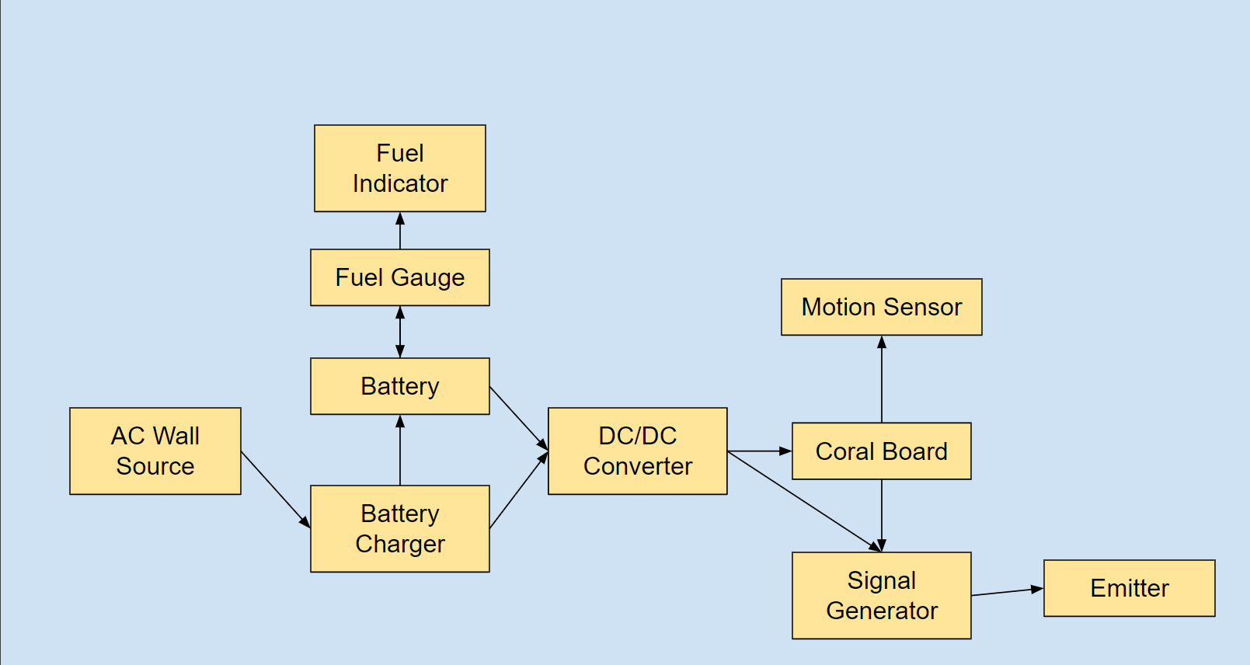

*Figure 1: Electrical Interface Diagram*

## 5.1 Primary Input Power

**5.1.1 Maximum Values**

| **Component** | **Voltage** | **Current** | **Power** |
| --- | --- | --- | --- |
| Coral AI dev Board / Camera | 5 V | 3 A | 15 W |
| Motion Sensor | 5.5 V | 100 uA | .55 mW |
| Battery Charger | TBD | TBD | TBD |
| Battery Fuel Gauge | TBD | TBD | TBD |
| DC/DC Converter | TBD | TBD | TBD |
| Signal Generator | 5V | 76mA | 380mW |
| Ultrasonic Emitter | TBD | TBD | TBD |

*Table 3: Maximum Power Delivery Values*

**5.1.2 Standard Operating Values**

| **Component** | **Voltage** | **Current** | **Power** |
| --- | --- | --- | --- |
| Coral AI dev Board / Camera | 5 V | 2 A | 10 W |
| Motion Sensor | 3.3 V | 90-100 uA | .297-.33 mW |
| Battery Charger | TBD | TBD | TBD |
| Battery Fuel Gauge | TBD | TBD | TBD |
| DC/DC Converter | TBD | TBD | TBD |
| Signal Generator | 3.3V | 37mA | 122mW |
| Ultrasonic Emitter | TBD | TBD | TBD |

*Table 4: Standard Operating Power Delivery Values*

## 5.2 Signal Interfaces

***5.2.1 Motion Signal Interface***

The motion sensor shall be connected to the GPIO pins found on the Coral Dev Board. These pins will be read as a control signal which will be sent to the camera system program. When the camera program receives the control signal, three photos will be taken and processed over the span of three seconds.

***5.2.2 Transmission Signal Interface***

The signal generator will receive a signal from the Coral Board. The Board will send a unique signal for each of the three pests it has detected. Once the signal generator receives the signal it will generate the appropriate signal for the transceiver to emit.

## 5.3 Video Interfaces

As mentioned in section 5.2.1, the camera will receive a control signal from the motion sensor, and take one photo per second to be processed within that given second. The camera will send an active array of size of 2582 x1944 which shall undergo compression before processing to a size of 640x640.

# 6. Communications / Device Interface Protocols

## 6.1 Host Device

The host device shall be the Coral AI dev board. The board has 11 GPIO pins which will be sufficient for our device’s needs. The Coral Camera has a separate connection point from the GPIO interface, allowing for more room for control implementation.

## 6.2 Device Peripheral Interface

The camera will be connected to the Coral AI board with a specially designed Coral compatible 24-pin flex connector. The connector contains 10 differential data ports for image data transmission. Pin 17 will be used for camera control, while a pulse signal through pin 23 will be used to reset the camera when booting.

The motion sensor has a single out pin which will be connected to the Coral Board’s GPIO interface to allow for device communication.

The transmitter will communicate with the host device in order to transmit the corresponding frequency needed to repel the found organism. Communication shall take place using the GPIO pins as well.

Smart Pest Repeller

Andrew Albritton

Michael McNeil

Melquisedec Ordonez

**Schedule and Validation**

REVISION – Draft

Interface Control Document

for

Smart Pest Repeller

Prepared by:

_____________________________

Author Date

Approved by:

_____________________________

Project Leader Date

_____________________________

John Lusher II, P.E. Date

_____________________________

T/A Date

**Change Record**

| **Rev.** | **Date** | **Originator** | **Approvals** | **Description** |
| --- | --- | --- | --- | --- |
| **0** | 9/25/23 | ALL |  | Draft Release |
| **1** | 11/29/23 | ALL |  | Validation Plan / Schedule update |

***Schedule:***

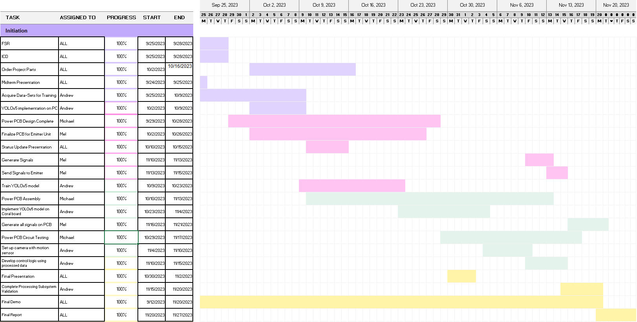

***Validation Plan:***

| **Task** | **Specification** | **Result** | **Owner** |
| --- | --- | --- | --- |
| Training Verification | Goal of 90%>= precision | PASS | Andrew |
| Camera Verification | Video taken by camera composed of 50 images | PASS | Andrew |
| Motion Verification | Ensure camera activates from motion control | PASS | Andrew |
| Camera MLA processing verification | Ensure correct items are detected and ignored during detection | PASS | Andrew |
| Post Detection Processing Verification | Ensure processing algorithm is functional given some error in detection (IE: ignore error in processing) | PASS | Andrew |
| DC/DC Voltage Converter Verification | Verify that converter can take in various input voltages and continue to output 5V and 2A |  | Michael |
| Battery Charger Verification | Verify battery charger charges battery |  | Michael |
| Fuel Gauge Indicator Verification | Verify fuel gauge tracks fuel and indicates when batteries need to charge |  | Michael |
| Power PCB Verification | Verify PCB circuit connects and system functions as intended |  | Michael |
| Signal Verification | Establish signal generator can produce the three separate frequencies required |  | Mel |
| Amplifier Verification | Verify signal is appropriately amplified before reaching emitter |  | Mel |
| Emitter verification | Make sure emitter can emit required frequencies |  | Mel |
| Emitter PCB verification | Verify circuit behaves like individually verified componentes did |  | Mel |

Smart Pest Repeller

Andrew Albritton

Michael McNeil

Melquisedec Ordonez

**Subsystem Reports**

REVISION – Draft

Subsystem Reports

for

Smart Pest Repeller

Prepared by:

_____________________________

Author Date

Approved by:

_____________________________

Project Leader Date

_____________________________

John Lusher II, P.E. Date

_____________________________

T/A Date

**Change Record**

| **Rev.** | **Date** | **Originator** | **Approvals** | **Description** |
| --- | --- | --- | --- | --- |
| **0** | 11/29/23 | ALL |  | Draft Release |

**Table of Contents**

**Table of Contents** **54**

**List of Tables** **55**

**List of Figures** **56**

**1.** **Introduction 57**

**2.** **Power Subsystem Report 58**

2.1. Subsystem Introduction 58

2.2. Subsystem Details 58

2.3. Subsystem Validation 59

2.4. Subsystem Failure Analysis 60/61

2.5. Subsystem Conclusion 62

**3.** **Detection Subsystem Report 62**

3.1. Subsystem Introduction 62

3.2. Subsystem Details 62

3.2.1.1 Model Characteristics 62

3.2.1.2 Model Validation 63

3.2.2.1 Coral Dev Board Implementation 64

3.2.2.2 Full Subsystem Validation 65/66

3.3. Subsystem Conclusion 67

**4.** **Signal Generation/Emitter Subsystem Report 67**

[4.1. Subsystem Introduction](https://docs.google.com/document/d/1iq4HAmX-esDczZtWkM9OUoNf8X_QaAYC/edit#heading=h.2bn6wsx) 67

4.2. Subsystem Details 67

4.3. Subsystem Validation 68

4.4. Subsystem Failure Analysis 70

4.5. Subsystem Conclusion 72

**List of Tables**

Table 1. Buck-Boost Switching Regulator Test Results

Table 2. Recorded Values for Battery Charger

**List of Figures**

# Figure 1. Block Diagram of Power Subsystem

Figure 2. Battery Fuel Gauge Schematic

Figure 3. Training Loss Diagrams

Figure 4. Training Validation Photos

Figure 5. Detection Subsystem Functional Diagram

Figure 6. Full Subsystem Results

Figure 7. Filtered Output at 1 KHz

Figure 8. Filtered Output at 40 KHz

Figure 9. Filtered Output at 55 KHz

Figure 10. Filtered Output at 70 KHz

Figure 11. Partial solder on vias

# 

1. **Introduction**

The Smart Pest Repeller will detect pests and then automatically respond to the pests present with the appropriate ultrasonic signal in order to deter pests from remaining in the target area. The system can be broken down into three major subsystems; power, signal generation, and detection subsystems. Each of these subsystems was designed and tested to varying degrees. Certain parts of the system have been tested and validated to match the requirements laid out in the ConOps, FSR, and ICD, while other parts of the system will go through some redesign over the coming weeks to address failures that occurred during testing and validation phase.

1. **Power Subsystem Report**

***2.1. Subsystem Introduction***

The power subsystem was designed to generate power and supply it to the rest of the system. The subsystem will have functionality for using wall power and battery power to power the system. When the system is plugged in to wall power it will run off of wall power while supplying charge to the battery. If the system is removed from wall power, the power subsystem will continue to power the board with battery power. Once battery charge is at a certain level, the system will indicate to the user that it needs to once again be connected to wall power to charge the battery. Each part of the power subsystem was tested and the results of validation will be discussed below.

***2.2. Subsystem Details***

The subsystem is composed of three main circuits; the fuel gauge, the battery charger, and the buck-boost switching regulator. A block diagram of the system is shown below.

**Figure 1:** Block diagram of Power Subsystem

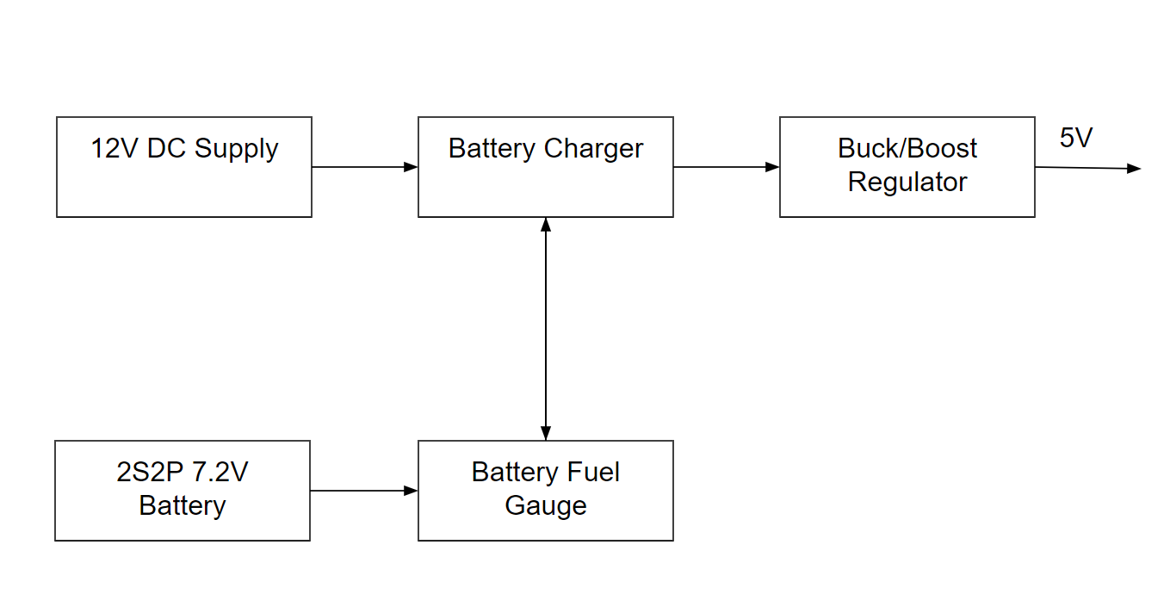

The primary challenge of the power subsystem is designing a system that was meant to work with both battery power and wall power. This was addressed by designing with a battery charger, the TI BQ24171, that has power path management, giving the subsystem the ability to switch between two different power sources.

***2.3. Subsystem Validation***

The buck-boost switching regulator was tested first to check for stability of the circuit. This was done by applying several different voltage values and using a digital multimeter to measure the output of the circuit to ensure the switching regulator was functioning properly. This is to test that the regulator implemented can take several different input voltage values and consistently output the same voltage.

**Table 1:** Buck-Boost Switching Regulator Test Results

| Input Voltage | Output Voltage |
| --- | --- |
| 3 V | 10.84 V |
| 5 V | 10.86 V |
| 7.2 V | 10.83 V |
| 12 V | 10.84 V |
| 16 V | 10.85 V |

The buck-boost regulator was able to output a consistent voltage reading in the output but unfortunately this output was steady at a much higher voltage than is desirable for the system to function properly. This test showed that the buck boost converter was capable of outputting a consistent voltage across different input voltage values but it failed to output consistent values needed for the system. This will be further discussed in the Failure Analysis section.

The battery charger was able to turn on and power was able to run through the system in certain parts but the main MOSFETs used in power path management were not being driven by the battery charger to turn on.

**Table 2:** Recorded Values for the Battery Charger

| Value | Recorded | Ideal |
| --- | --- | --- |
| VREF | 3.9 V | 3.3 V |
| OVPSET | 1.054 V | 0.5 V < X < 1.6 V |
| AVCC | 11.99 V | 4.5 V < X < 17 V |
| Output | 0.400 V | 7.2 V < X < 12 V |

From the values recorded in the table, it can be observed that the IC itself was able to turn on and generate a voltage reference close to the reference desired. The pin that also detects a fault of any kind (OVPSET) was also within acceptable parameters to not be throwing a fault error. These individual parts of the circuit all work as intended but the output of the charging circuit is far lower than the desired output to the regulator. The proposed solution and redesign for this will be discussed in the Failure Analysis section.

The battery fuel gauge was connected to the MCU and tested but there were issues getting any sort of connection or important data through the I2C communication. This will be more thoroughly discussed in the Failure Analysis section as well.

***2.4. Subsystem Failure Analysis***

The subsystem did not function as intended and these faults are to be addressed in the redesign of the system that will occur in the near future. The first fault to address is the issues with the buck boost switching regulator. This fix will be relatively simple as the issue seems to be with one of the feedback resistors on the regulator circuit. Once this has been adjusted, it should start to function properly.

The battery fuel gauge will need to be redesigned at the schematic level. The schematic for the battery charger as it is currently designed is below.

**Figure 2:** Battery Fuel Gauge Schematic

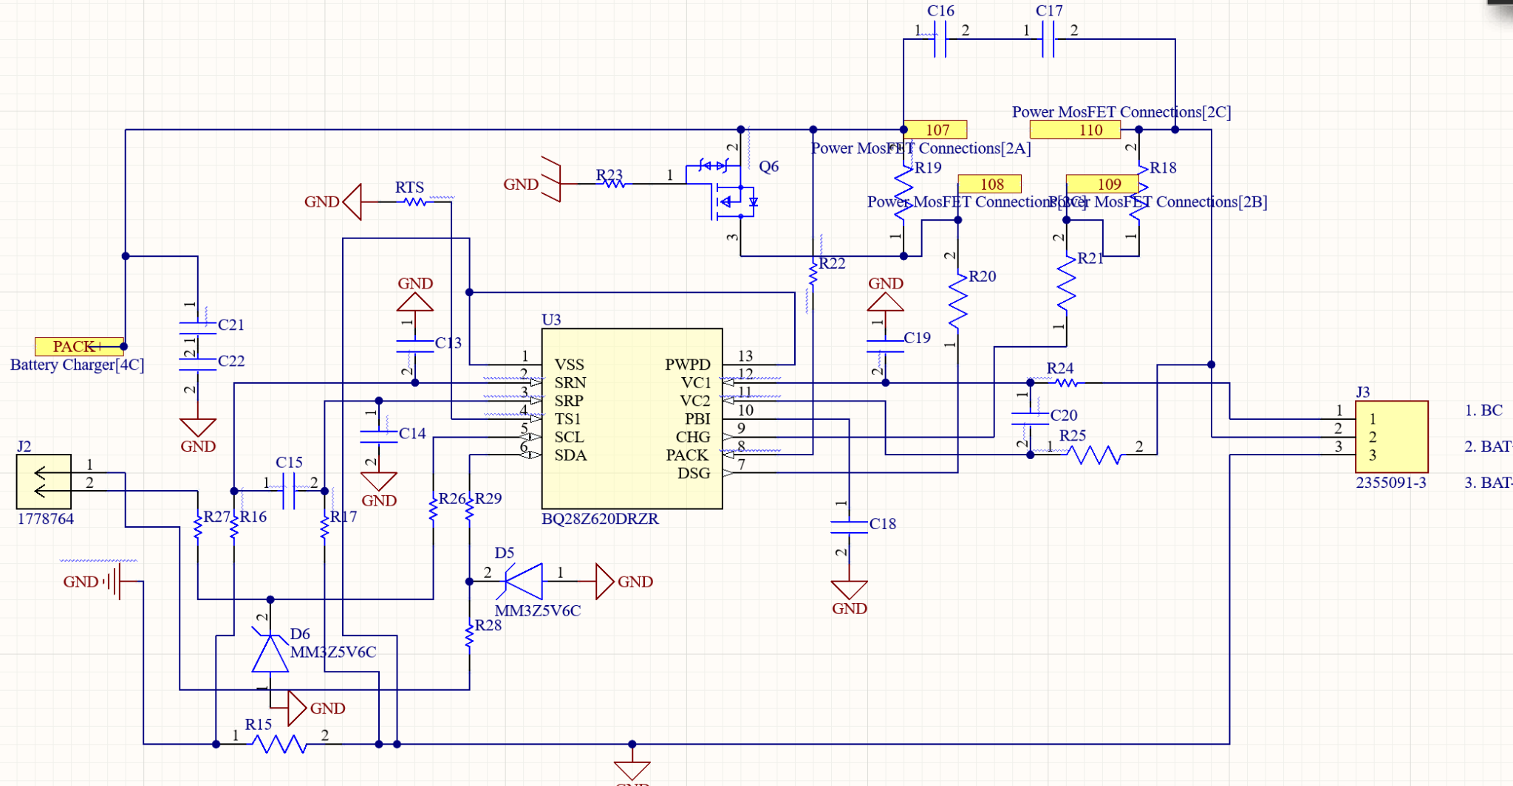

The battery fuel gauge schematic is currently configured for a battery that is of the 2S variety. While our system’s battery power supply is a 2S battery, when applying it to a circuit, it should be treated as a 1S battery so the fuel gauge will need to have a slight redesign from a 2S configuration to a 1S configuration. This should be able to be done without changing parts as the fuel gauge used, the BQ28Z620, is compatible with both 1S and 2S configurations. Once this is done the fuel gauge should be able to properly connect and communicate with the MCU via the I2C communication connections.

The battery charger also was not able to function properly. The issue at play in the battery charger is that the IC does not drive the MOSFETS used for power path management to turn on. This is likely due to a burnout sense resistor as the IC can not sense voltage across these resistors so it can not detect the presence of a power supply or a battery to charge. This will be addressed in the redesign by changing out the part sizing used for resistors and capacitors of this circuit. Most of the resistors and capacitors chosen for this circuit as well as the fuel gauge circuit were of the 0402 variety. These resistors and capacitors are extremely small and difficult to work with. With these limitations it is easy to burn out resistors and capacitors of these sizes so the redesign will change these sizes to larger sizes to help prevent this issue from happening again in the assembly phase.

Other design considerations that are being taken for the redesign include changing all of the wire to board connectors to something that is easier to use and less dangerous. The connectors used in the first design were quite small and made connecting the battery as well as the communication wires much more of a hassle than it was worth and this caused both time delays and extended processes that did not need to be extended. With this small redesign, this issue should be easily mitigated in future design.

***2.5. Subsystem Conclusion***

Overall the subsystem did not work as expected. Over the coming weeks the subsystem will be redesigned with the measures covered in the failure analysis section incorporated into the system. Once the subsystem redesign is complete and validated the subsystem can then be implemented with the other subsystems and allow for the system to run continuously for long periods while monitoring for the presence of pests in the target area of the system.

1. **Detection Subsystem Report**

**3.1 Subsystem Introduction**

The Detection Subsystem provides the means by which images can be taken and read to find the correct frequency that needs to be generated from our Signal Generation Subsystem.

**3.2 Subsystem Details**

**3.2.1.1 Model Characteristics**

When a model calls for image processing a convolutional neural network must be used. My choice of model was the YOLOv5s pre pre-trained model. Using a pretrained model accelerates train time when undergoing training using a custom dataset. The dataset used for training is composed of 8974 images and 10 labels. The link to my dataset and sources of images can be found in the link below:

<https://universe.roboflow.com/texas-am-at-college-station/smart-pest-repeller-detection>

The labels of interest for our device are, Squirrel, Lizards, 0, aphid, fly, and rat. The other labels included prevent the model from mistaking a person as a squirrel for example. After training the model is exported from a PyTorch format to that of TensorFlow LITE (int-8) for Coral TPU compatibility.

**3.2.1.2 Model Validation**

Results from training yielded a cls_loss of below .01 which fits well within our goal of <90% precision after training. These results can be found in the figure below:

**Figure 3:** Training Loss Diagrams

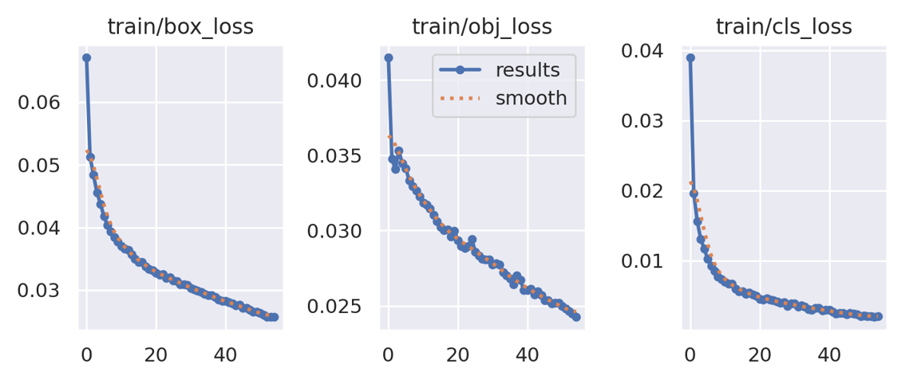

After training, the TensorFlow LITE version of the model was tested for generalization on images not used in the training dataset, and the results shown were promising, showing correct classification of desired objects found in the provided images. The model often confused rats and squirrels with one another, but this behavior is still desired as the needed output frequency corresponding to either animal is the same. The last image shows the model processing an empty photo and nothing being detected, which is the desired behavior.

**Figure 4:** Training Validation Photos

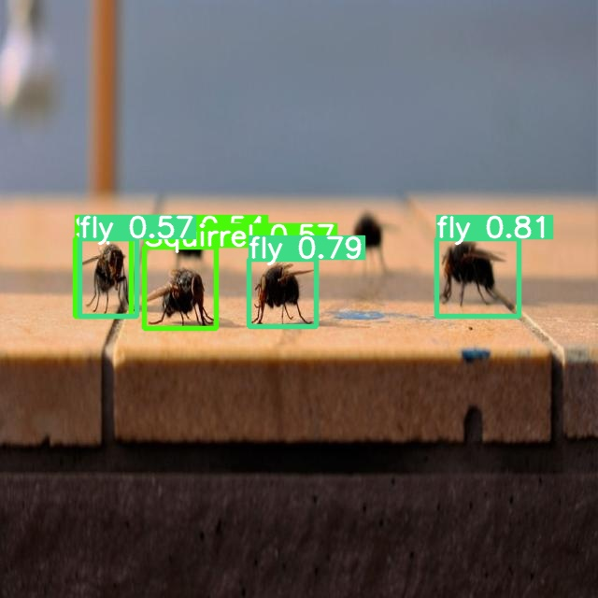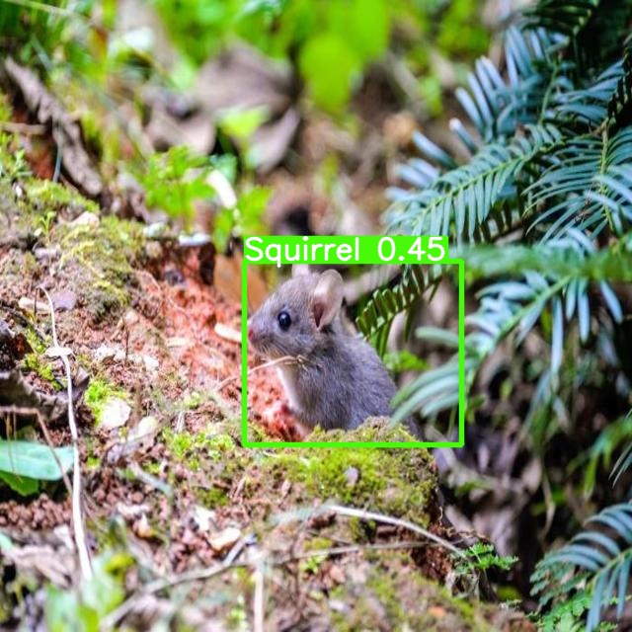

**3.2.2.1 Coral Dev Board Implementation**

Google’s Coral AI Dev Board is only compatible with TensorFlow, so some changes needed to be made to the code used to run the model for detection. In order to do this I forked a GitHub repository made by “jveitchmichaelis” named edgetpu-yolo. This repository won the Ultralytics competition for edge device deployment. However, some changes needed to be made in order to use this repository for our project. The added capabilities to this code base included the ability to save a video of detected items, a csv of detected items with corresponding probabilities, and ability to take 50 photos with an external camera for detection. With these additions made to the detect.py script, the control.py script would be able to function properly, and the model will use the Coral Board’s TPU for real time detection. The control.py script’s functionality is shown in the diagram below. In ECEN 404 I plan to make this function run on startup of the Coral Dev Board.

**Figure 5:** Detection Subsystem Functional Diagram

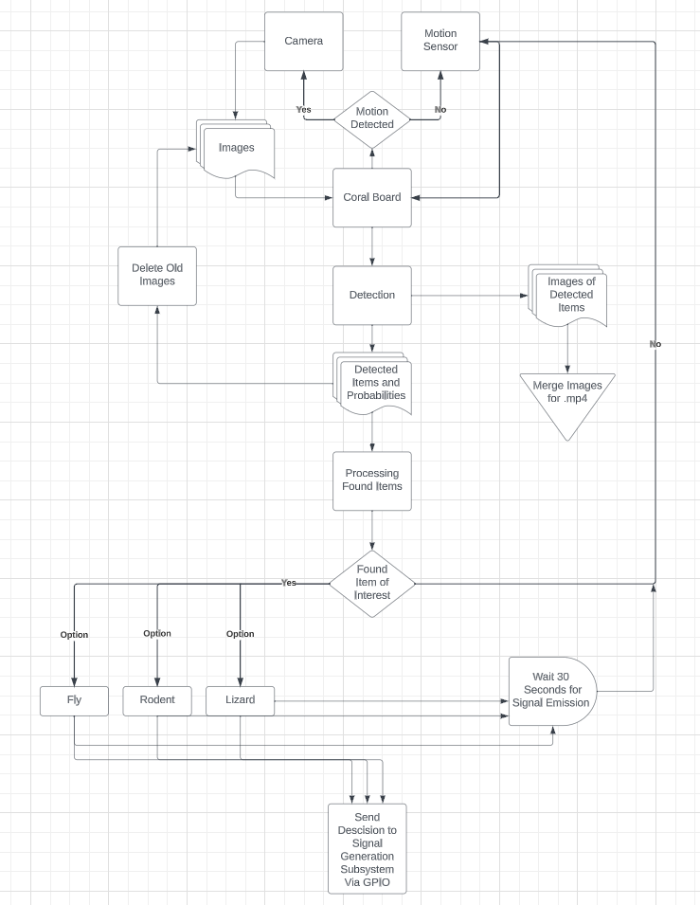

**3.2.2.2 Full Subsystem Validation**

For testing the finished subsystem, the motion sensor and camera were connected to the coral board to test if the included model would recognize the correct animal held in the camera's view. Each time detection was started by triggering the motion sensor, and each time the camera took 50 photos to run for detection. Screenshots from each test case can be found below (these images were taken from the created .mp4 videos that are made after detection is done on all 50 images in a single run).

**Figure 6:** Full Subsystem Results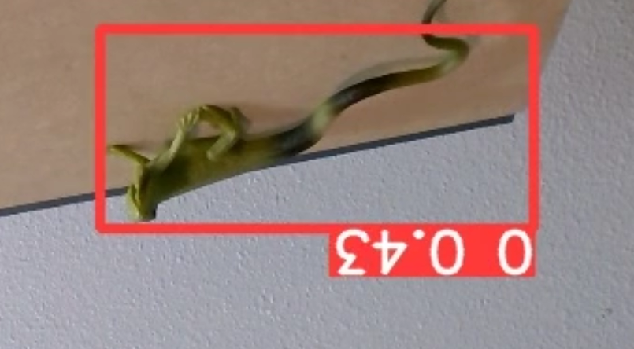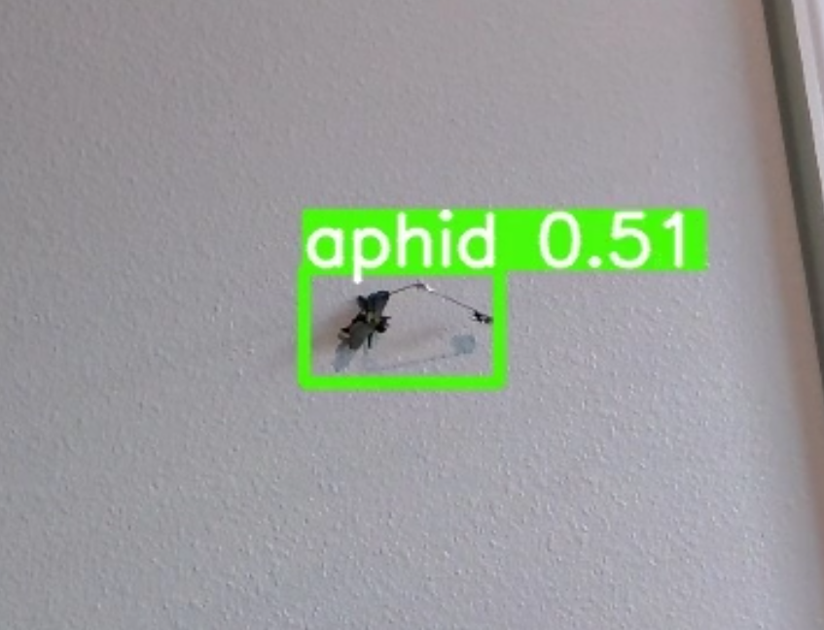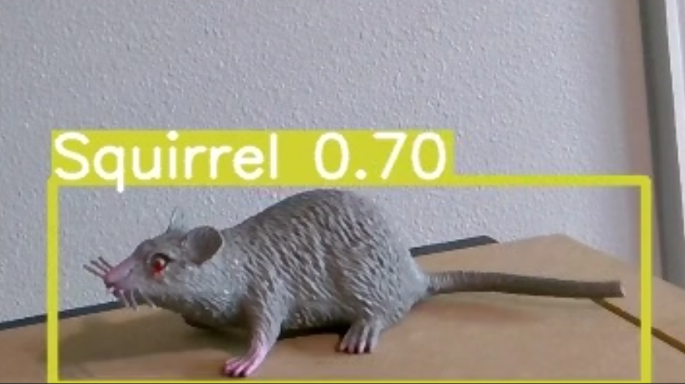

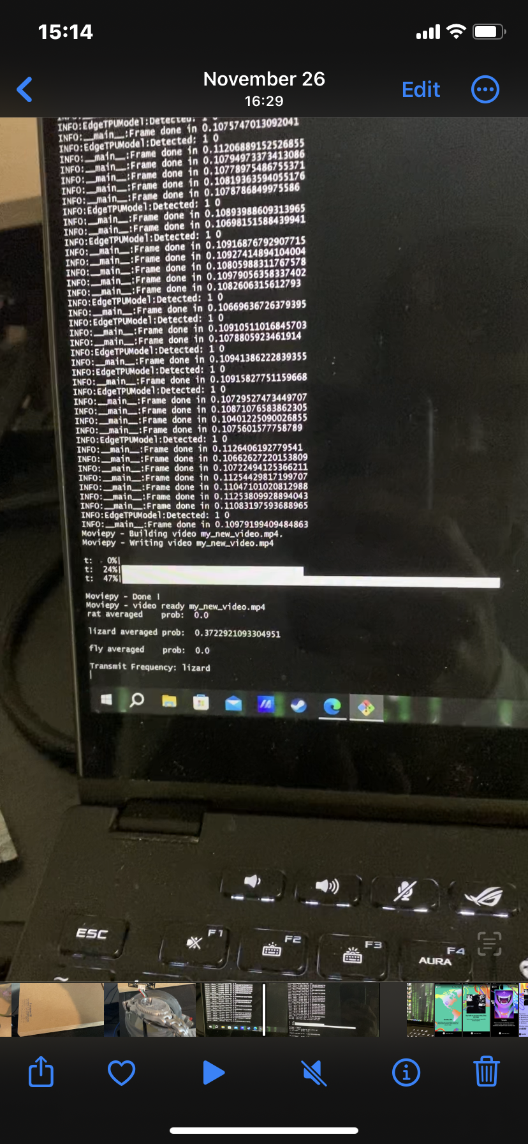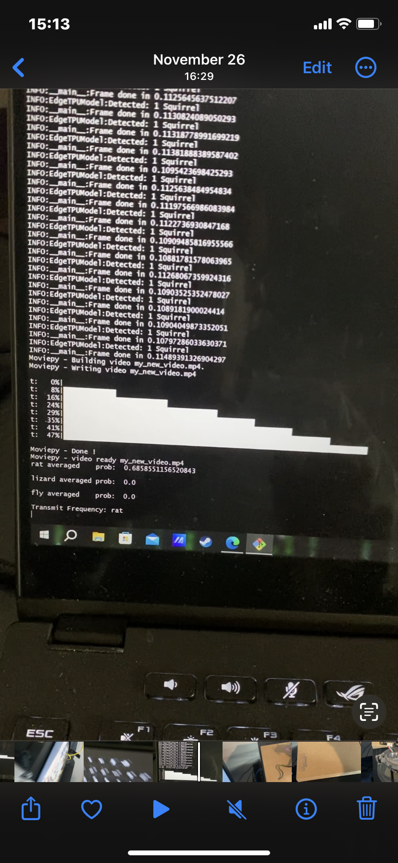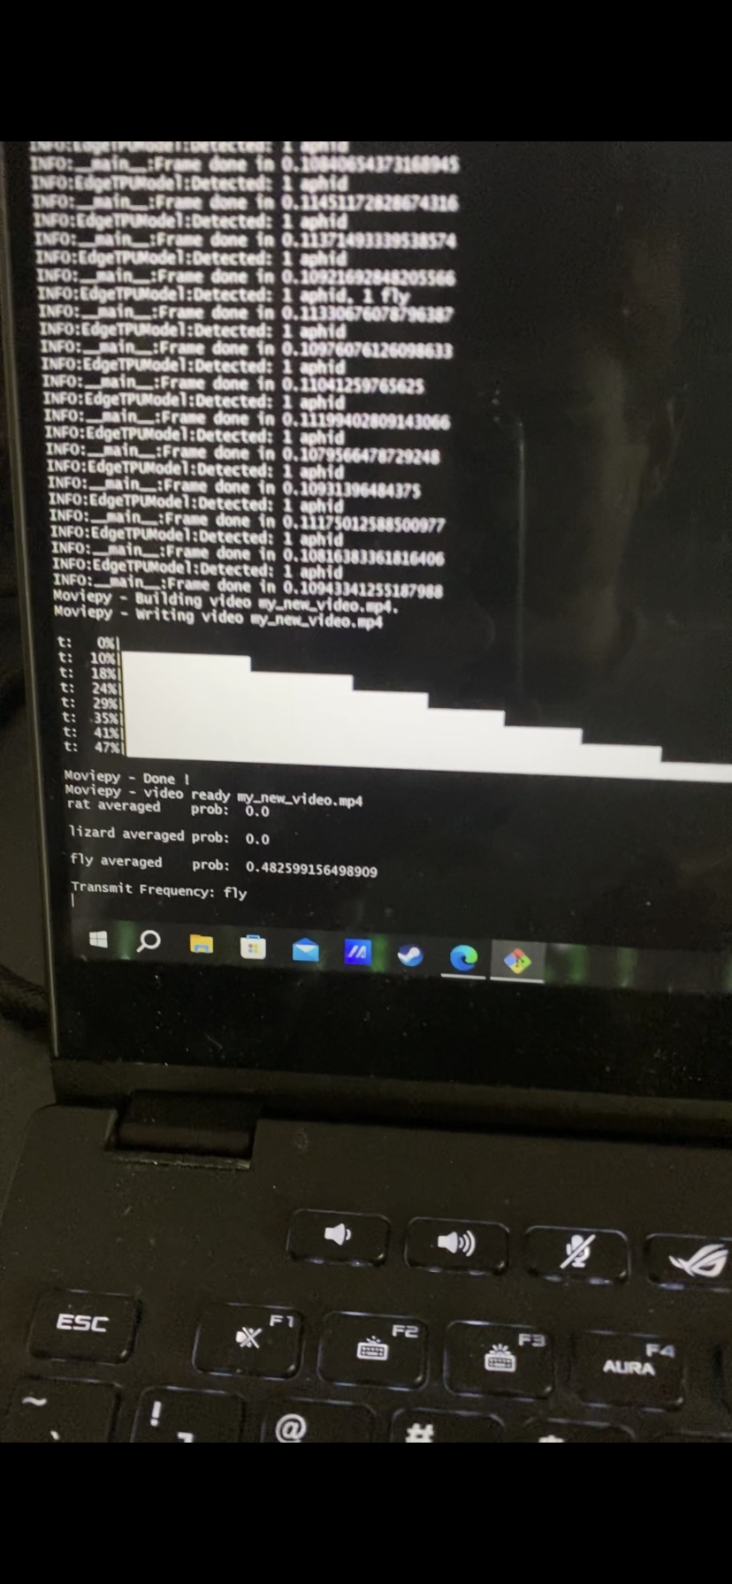

The “0” label was used to denote “small-lizards”. The “Lizards” label that is separate from this one is meant for large species of lizards like Iguanas. In each of the images above, the model is able to correctly classify which organism is present when using the included camera rather than pre-saved files. This demonstrates proper behavior from the camera, motion sensor, post data processing, and ML model.

**3.3 Subsystem Conclusion**

The Detection Subsystem was successful in showing its ability to detect motion and the organism creating this motion. Items left to finish before full system integration include: adding control.py to boot sequence, changing output from “organism name” to the corresponding GPIO signal needed from the signal generation unit, and building a device to turn the board off and on. The Coral Board does not have a simple switch to turn it on and off, rather it needs to have a command sent through its shell in order to properly close open processes. This will be done using an Arduino to send a signal through GPIO that interrupts the control.py script and tells the board to shut down. After this is done the board’s supply power will then be closed from a relay controlled by the arduino. This will ensure the board will safely be able to power on and off without interacting with the board’s console.

1. **Signal Generator/Emitter Subsystem Report**

**4.1 Subsystem Introduction**

This subsystem is meant to produce the signal that the ultrasonic emitter uses to repel the pest that the detection subsystem finds. The pest comes in three categories (flies or other bugs, lizards or other reptiles, and mammals like rats) that correspond to three frequencies( ~40KHz, ~55Khz, and 70 Khz respectively). The emitter subsystem will send the appropriate signal corresponding to the label given to the pest identified by the detection subsystem. The signal comes in the form of a smooth filtered sine wave at the appropriate frequency. This signal is then supplied to an ultrasonic emitter that converts the digital signal of the wave to an analogue sound signal at the same frequency that is used for repelling the appropriate pest.

**4.2 Subsystem Details**

The signal generation came from the AD9850 DDS module. This module was chosen for its relative ease of use and its ability to produce signals in the desired frequency range, about 40Khz - 70Khz, that are needed for this system. This system produces four signals. Two are sines where one is complementary to the other at the same frequency. Two are square and are again complimentary at the same frequency. Although not technically required, a 60 Mhz clock was used as the reference for this module.

For cost purposes only one filter was used and therefore one signal was able to be filtered, in this case one of the sine waves.The filter is controlled by placing a digital high or low signal, in this case +5V to 0V, to the filter control pins, four each for both filter cutoff frequency and gain. The filter used for this subsystem was the LTC1564CG#PBF. It is a variable controlled low pass filter and amplifier from 10 Khz to 150 Khz and 1 to 16 V/V respectively. The cutoff filter frequency and gain control are both adjusted in the same manner. Four control pins yield 16 possible values which in the case for the filter corresponds to 0000 for 10 Khz and 1111 for 150 Khz with 10 Khz steps in between. For the amplifier 0000 corresponds to unity gain and 1111 corresponds to 16V/V gain with 1V/V steps in between. The filtered signal is then sent to the emitter used for repelling.

**4.3 Subsystem Validation**

The system validation included verification that the filter was able to produce a smooth sine wave signal at several frequency ranges up to 70 Khz and as well as effectively filter out higher frequency, > 70 Khz, noise and variably amplify the signal. To test the emitter the AD9850 would be controlled to sweep across the audible hearing range for humans, about 1-20 Khz, and hear if the emitter would start at low frequencies and end at high ones.

**Results:**

The subsystem was not able to produce the necessary signal needed for the emitter to generate noise. The signals produced were incredibly noisy and vaguely resemble sine waves at best let alone the smooth ones that are required for this subsystem, as is shown below.

**Figure 7: Filtered output at 1 Khz**

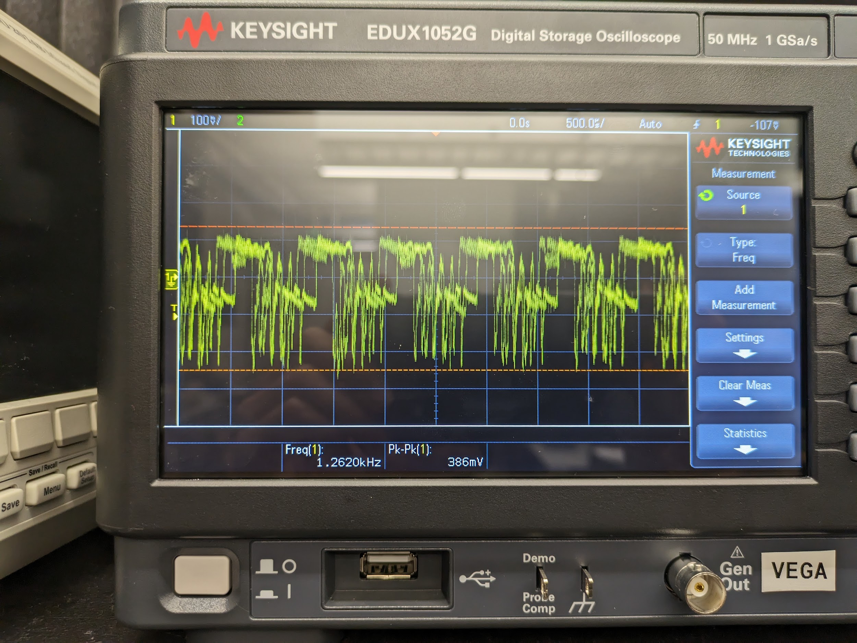

**Figure 8: Filtered output at 40 Khz**

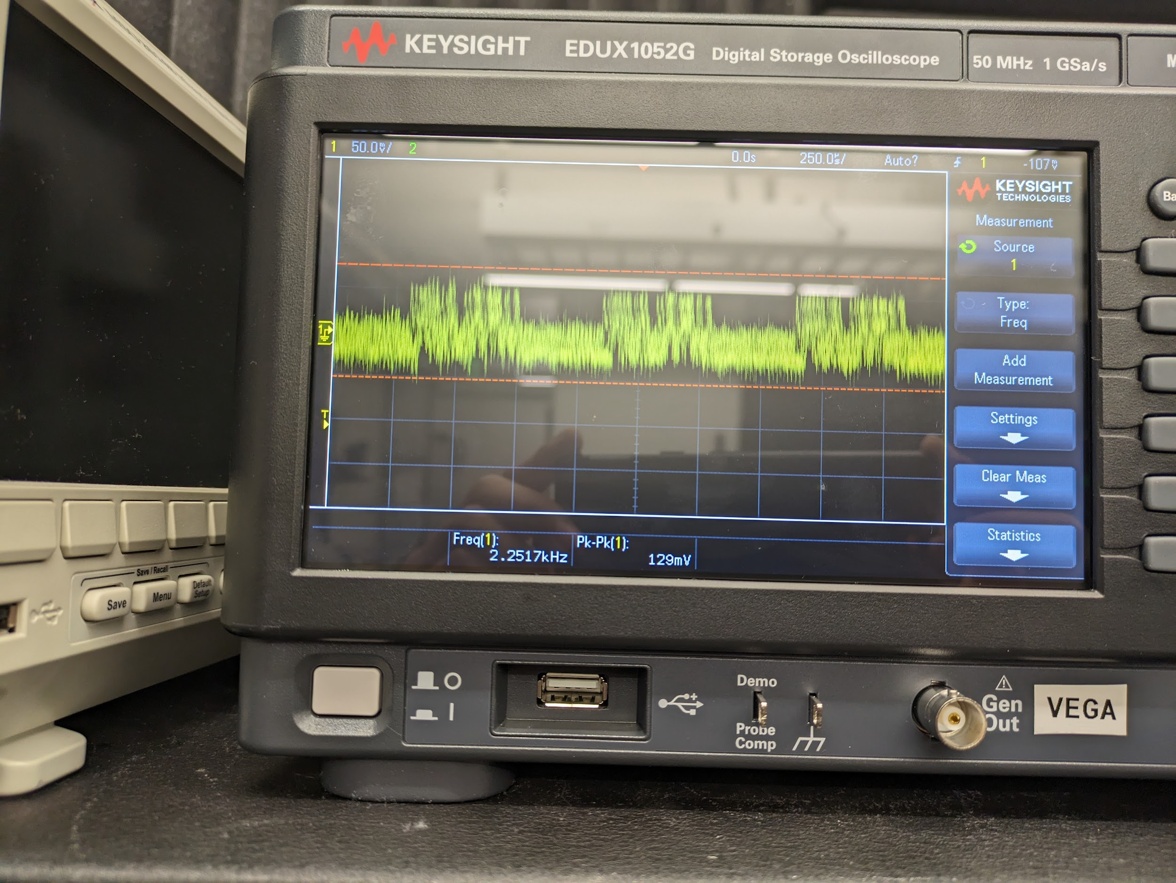

**Figure 9: Filtered output at 55 Khz**

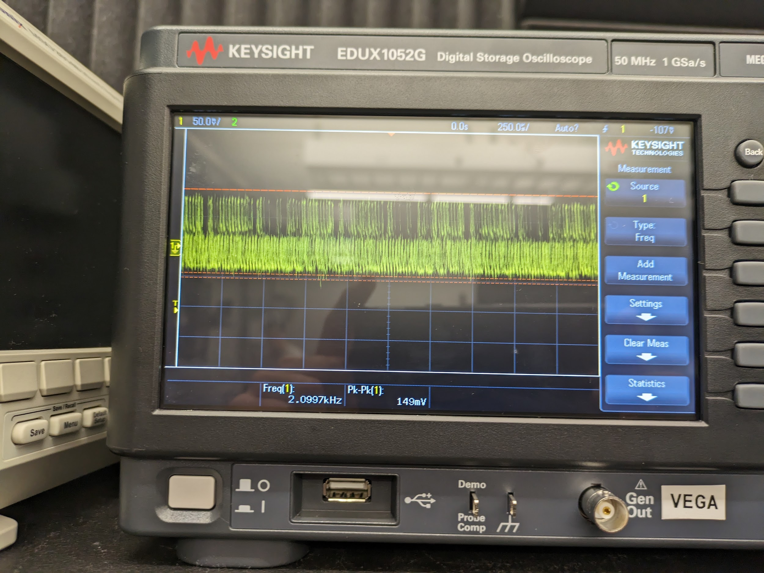

**Figure 10: Filtered output at 70 Khz**

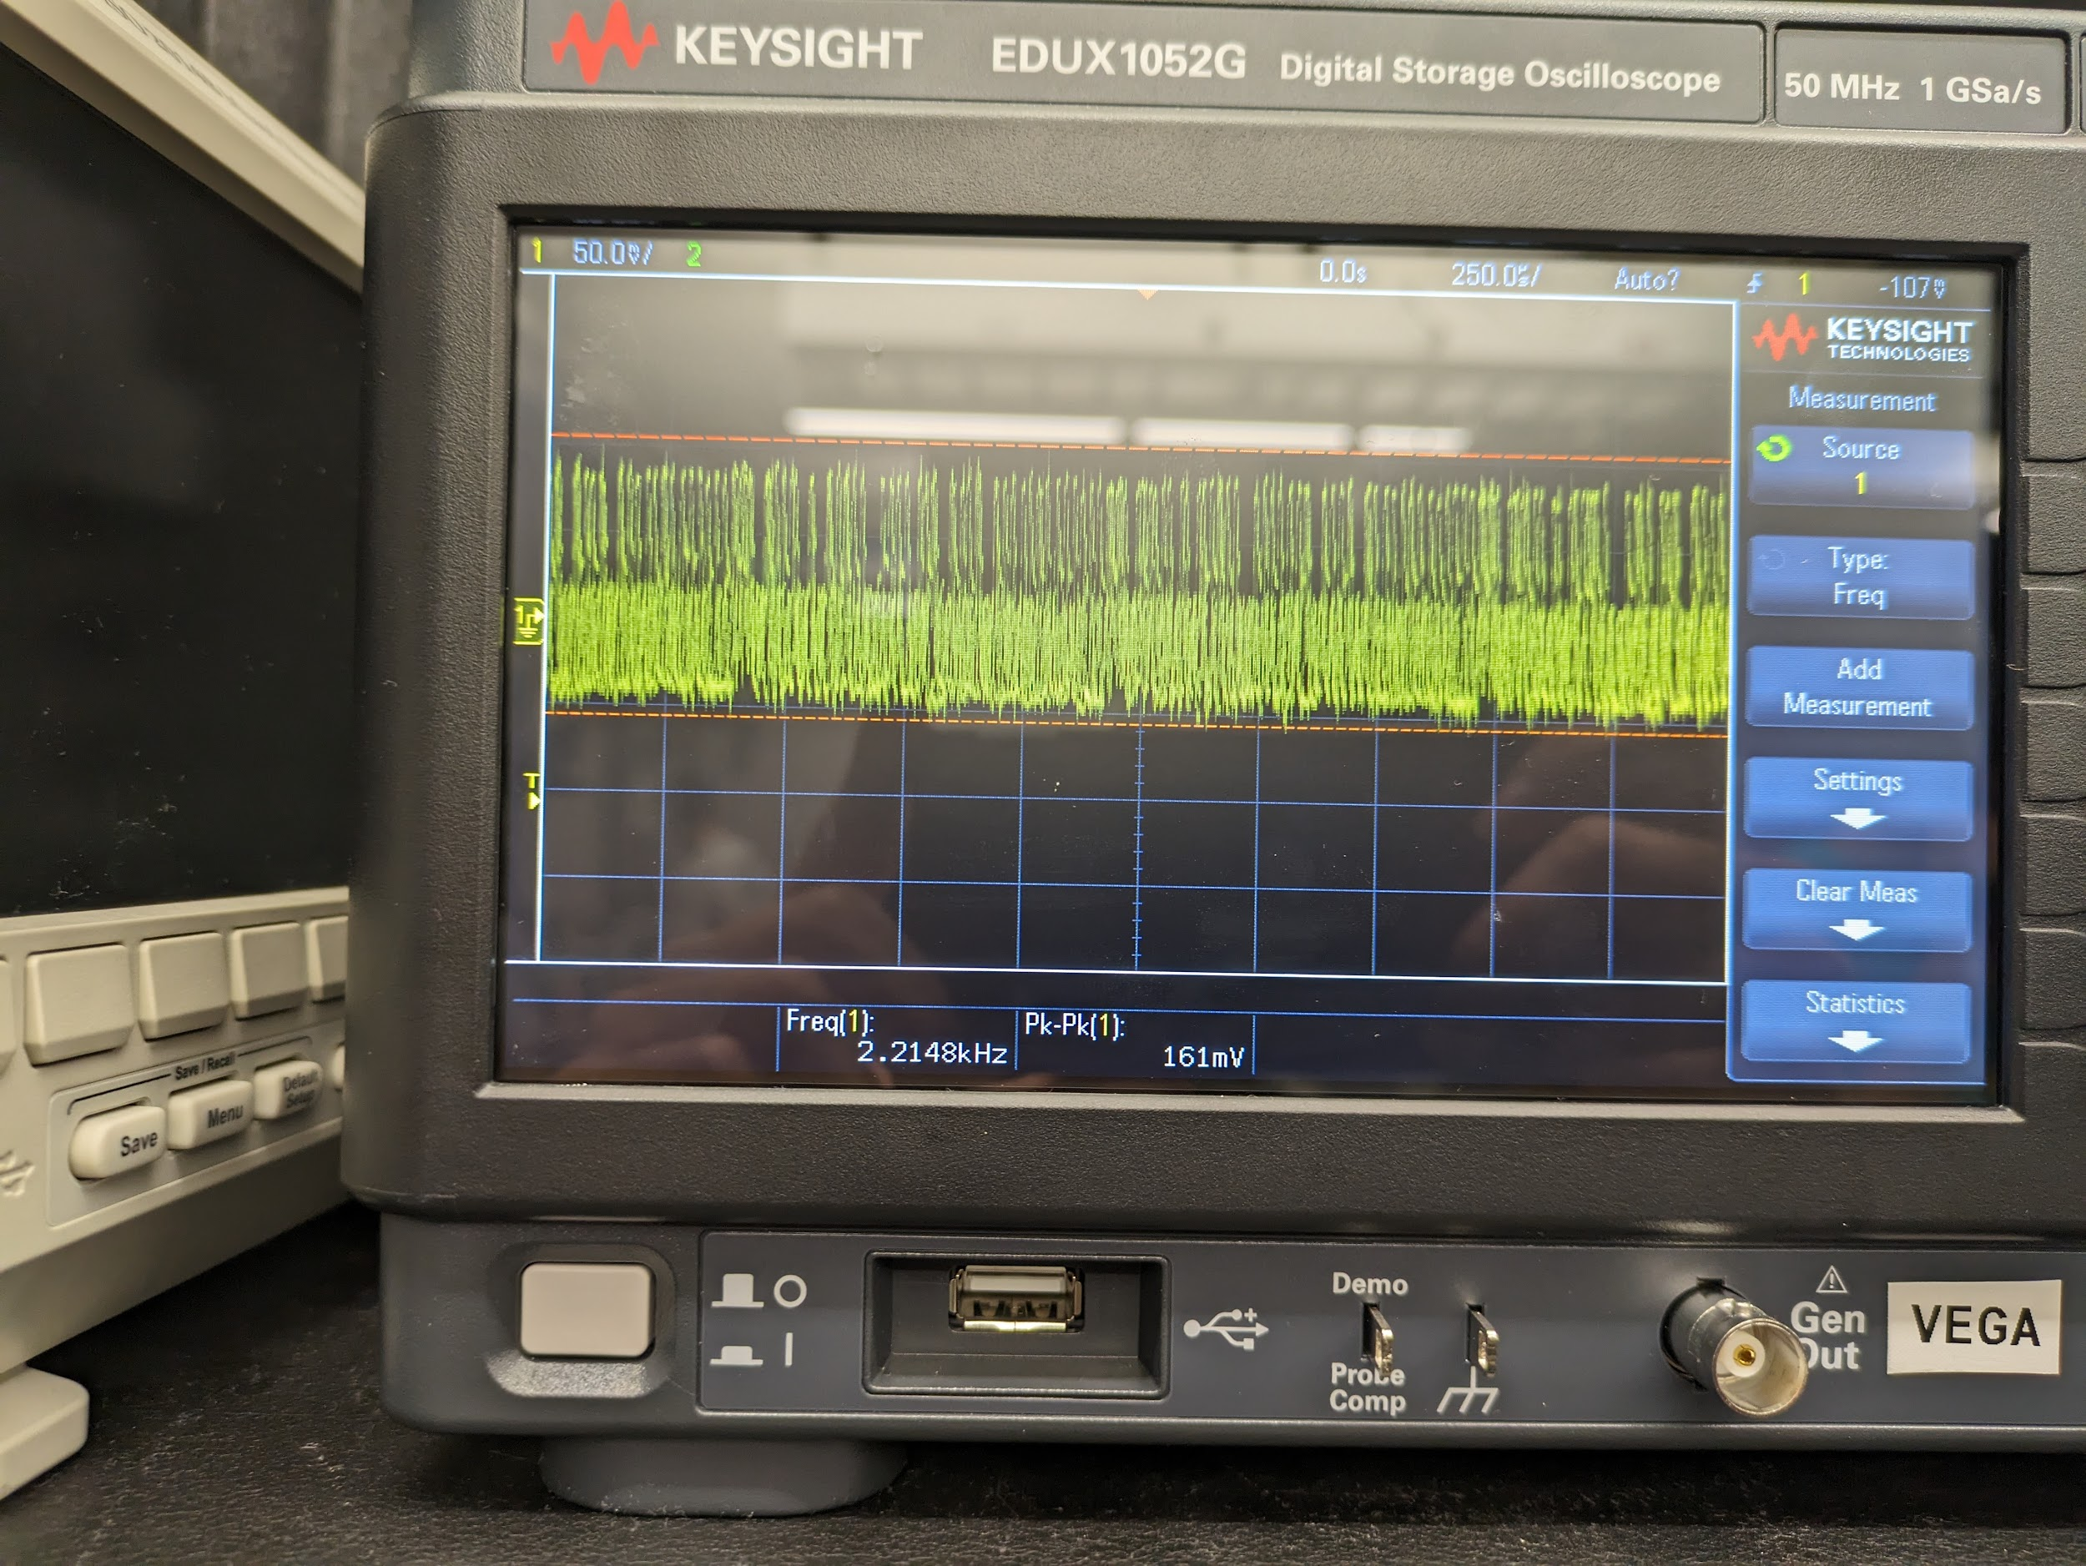

As can clearly be shown the signals generated are unusable in their current state. Past 1 Khz the signals become so noisy that they no longer even resemble a sine wave. On occasion they would become somewhat of a smooth sine wave but they were not stable and would quickly become noisy again. Also of concern was that no matter what signal that was attempted to be generated past 2 Khz the signal measured would never go above a 2 Khz frequency and there was a noticeable dropoff in power past 1Khz signal as well. The signal was still sent to the emitter for testing however, and as expected given the signal used, the emitter was not able to produce any noise after sweeping through the audible hearing range.

**4.4 Subsystem Failure Analysis**

The signal that resulted from the filtered output was still very noisy and unstable. A probable cause for this would be the method for how the filter inputs for gain and frequency were implemented. In order to have 8 total connections for the filter, four each for the filter and gain control, a bread board was used as there were not enough connections on the PCB itself to handle this. The board used was quite old and used in previous courses that occasionally had problems as well with producing noisy signals on them. Of note as well during soldering was that a bit of solder accidentally covered a few of the vias on the board itself and would not completely come off using a soldering wick. A hot air station was available but over concern of the vias proximity to the IC used this method was not used ultimately. In a redesign morecarful attention will be placed when soldering components.

**Figure 11: Partial solder on vias**

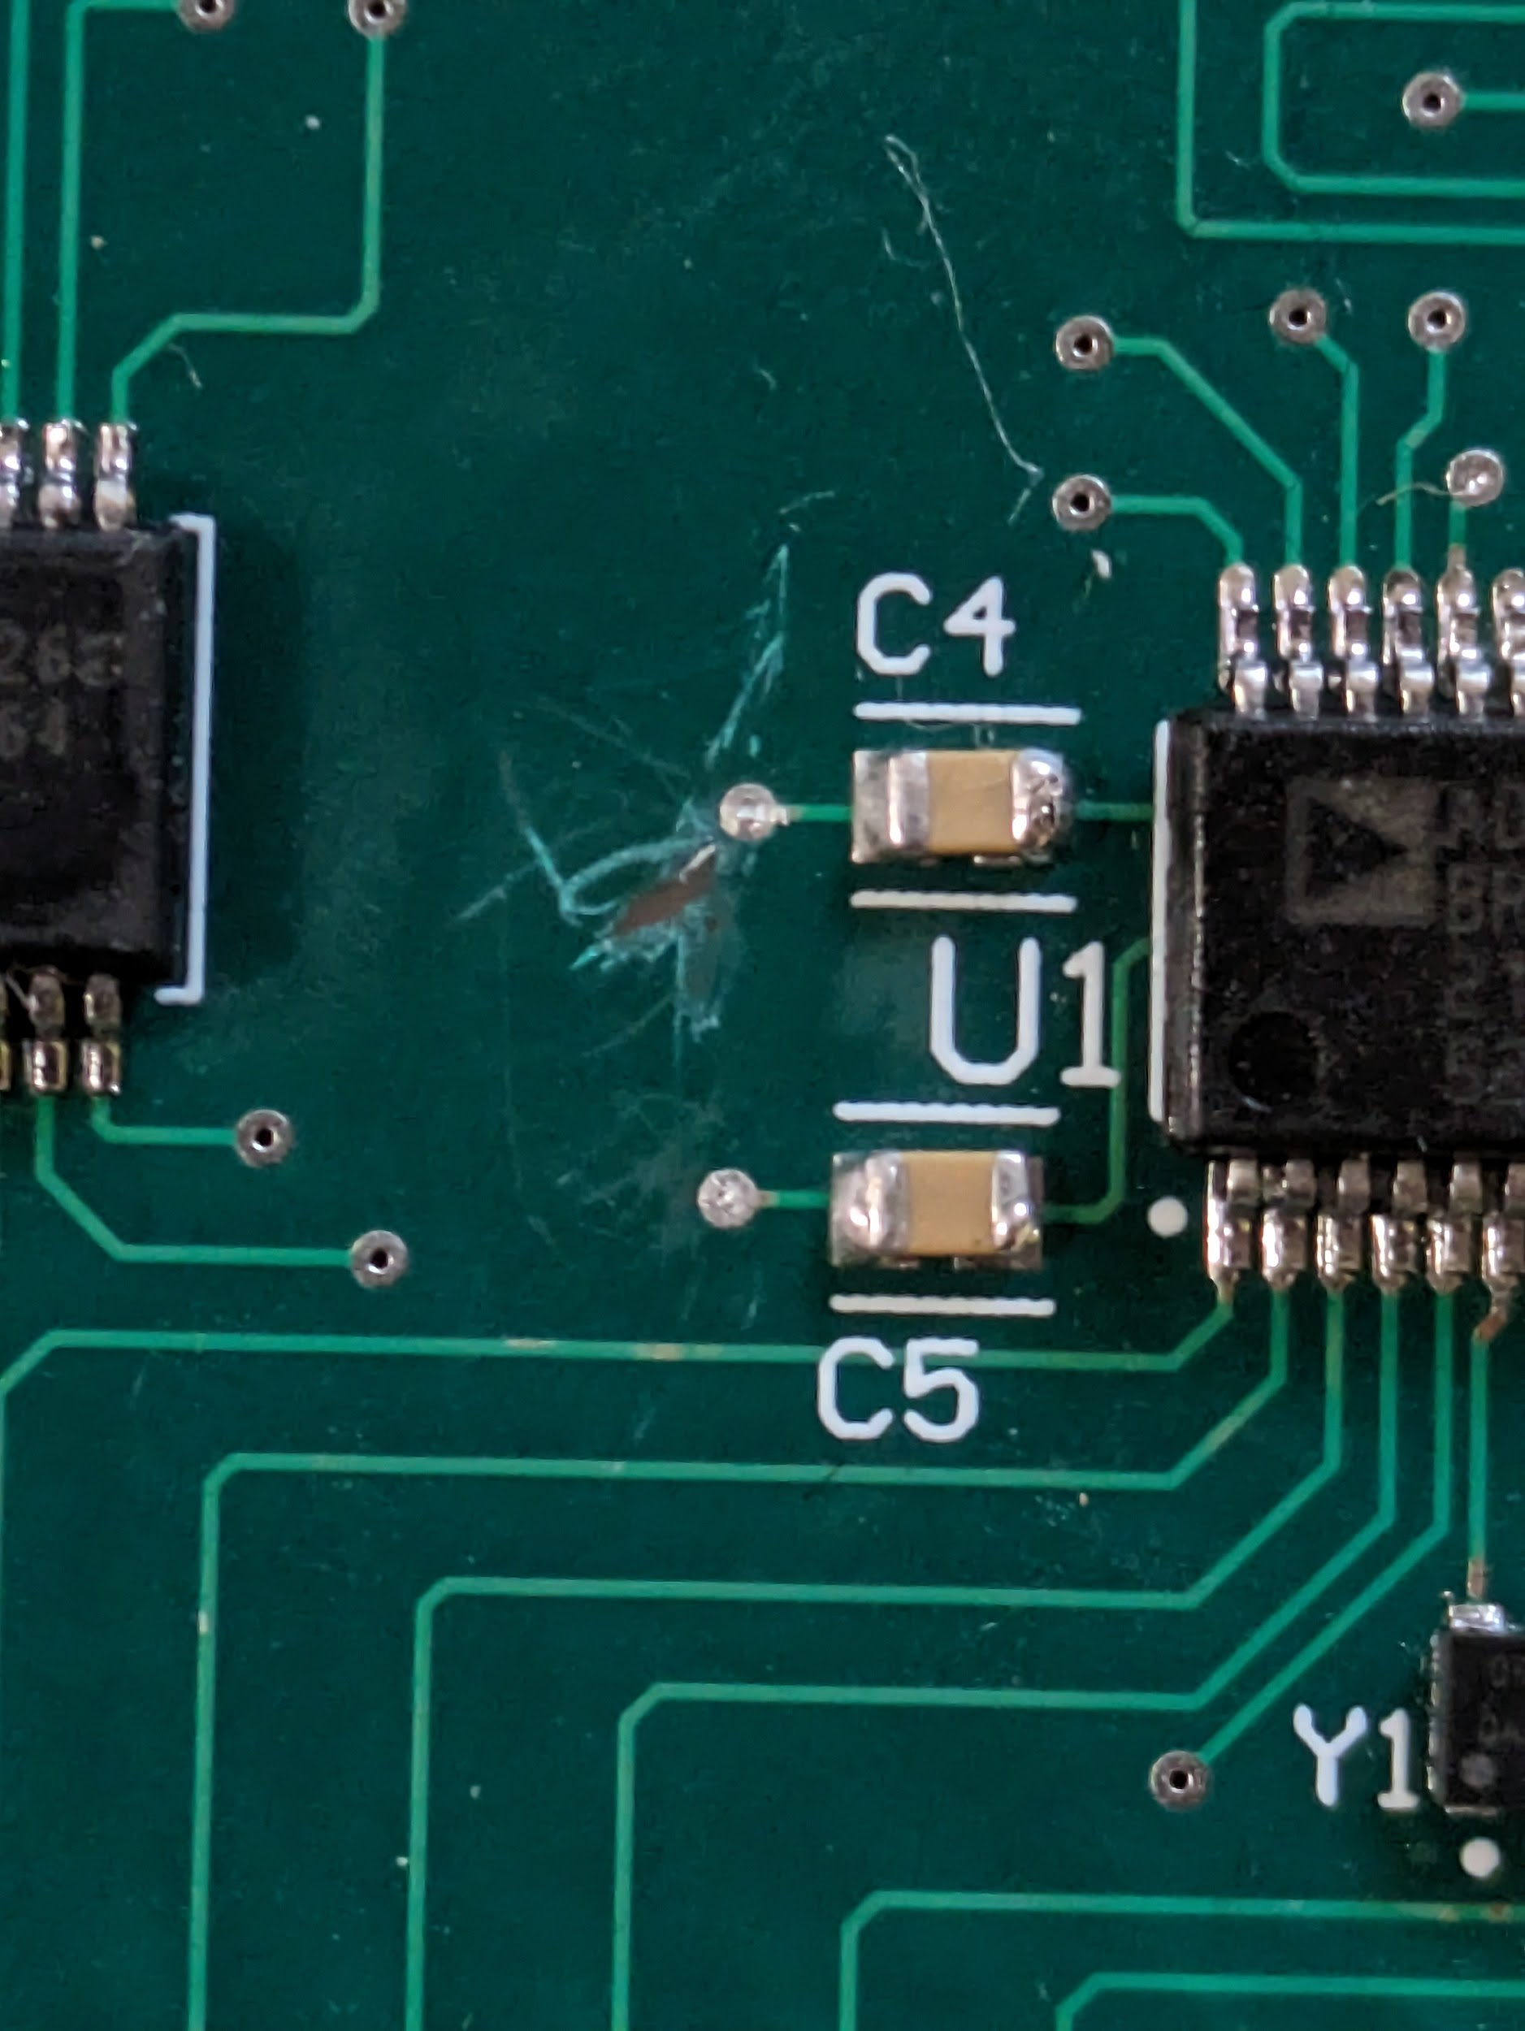

To remedy this problem in a redesign of the board, the filter inputs for controlling the filter can be hardwired onto the board itself.This would get rid of the need to use the breadboard as a source of possible noise. Alternatively and what may end up happening is an individual filter may be designed specifically for the board using physical resistors and capacitors to rid the need entirely of the wire entirely for the filter. The control of the AD9850 however will need a wired connection as the microcontroller that will control it is housed in a separate board from the one used for the emitter. However, assuming the breadboard was the major source of noise this should not be a major issue.

**4.5 Subsystem Conclusion**

The emitter subsystem did not function as was expected or needed. The filtered signal that was measured was still very noisy and unstable. This likely resulted from the use of an old bread board that used to send the digital signal for the filter. In a redesign of this system a personal filter will most likely be designed to ensure that no cables are needed and greater control of the board is ensured. Additionally, a different clock may be used as well as evaluation boards with the AD9850 tha function well typically used crystal oscillators whereas the board used was a CMOS crystal.